LUGONGOLWENI INKHUNDLA HOSTS MINISTER OF SPORT CULTURE AND YOUTH AFFAIRS IN an EXCITING SHUKUMA eswatini activity. |  | 2019 FIRST SHUKUMA ESWATINI  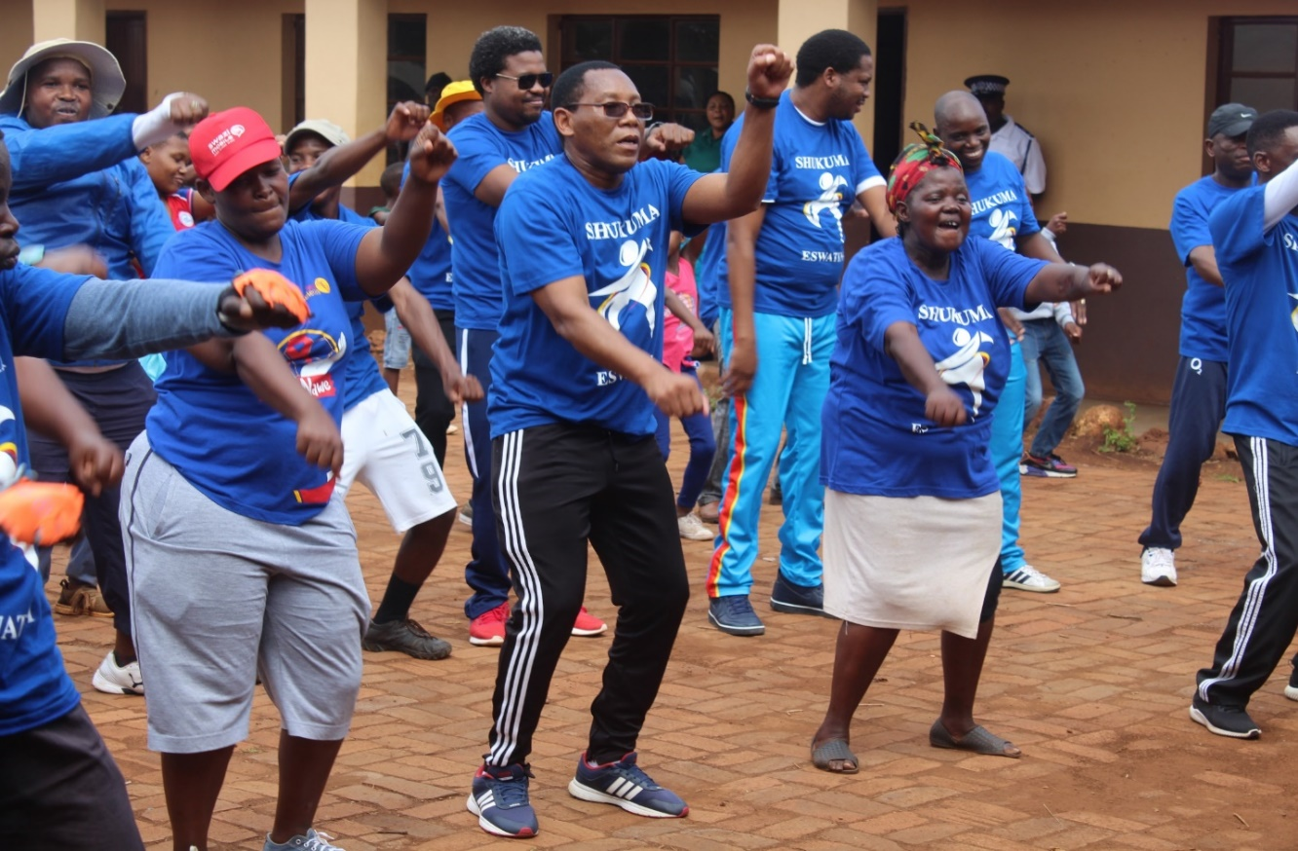
Page 1  Updates on 2019 ‘s first Shukuma Ewastini participation.  Page 2  More activities during Shukuma event.  Page 3  Updates on upcoming 2019 National Sports Awards. |  |  |  | sHUKUMA ESWATINI INVADES LUBOMBO  “A healthy body is a healthy mind”  Saturday the 23rd of February 2019 Shukuma Eswatini invaded the Lugongolweni Inkhundla in Siteki in the Lubombo Region. This was the first Shukuma of 2019.  Residents came in their numbers for this special day, which was graced by the Minister of Sport, Culture and Youth Affairs Harris Madze Bulunga. Over 300 people were part of the fun filled day .Amongst the enthusiastic participants were the likes of Principal Secretary Prince Mlayeto, Lugongolweni member of Parliament Thethi Magongo and Swaziland National Sport and Recreational Council (SNSRC) Chief Executive Officer (CEO) Darius Dlomo.  Marking the start of activities on the day was a 10km walk, which started from St. Boniface Primary School to Siteki Town and back. After the walk, Aerobics took center stage before the other Sporting activities that included Kids Athletics, Egg and spoon race, Rope skipping, tug of war and other fun games.

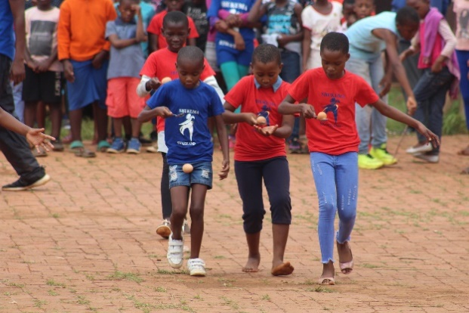  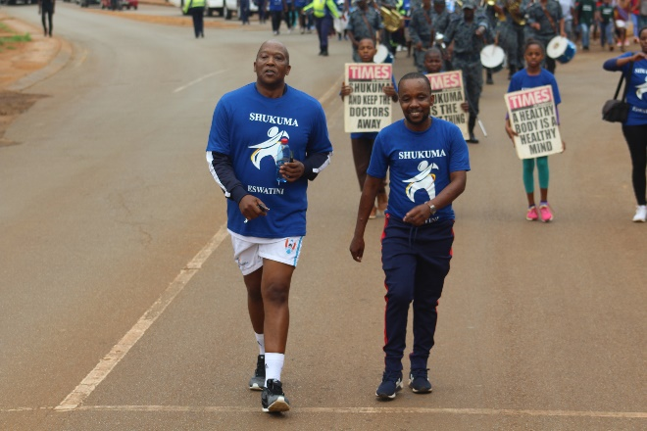  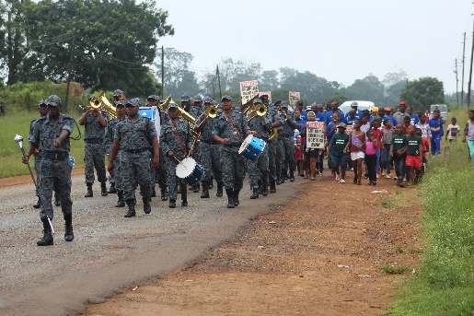  Egg racing was the children’s favorite fun game.  10 KM WALK  EXCITING ACTIVITIES  “YOUR BODY CAN STAND ANYTHING. IT’S YOUR MIND YOU HAVE TO CONVINCE’’ |  | Tug of war  MINISTER OF sport culture and youth affairs his honerable harris madze BULUNGA TAKING part in the tug of war.  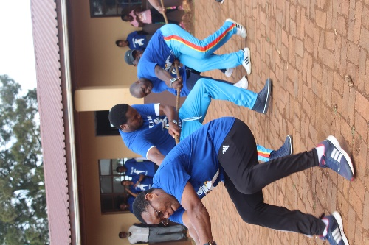  kids’Athletics Children were encouraged to keep fit  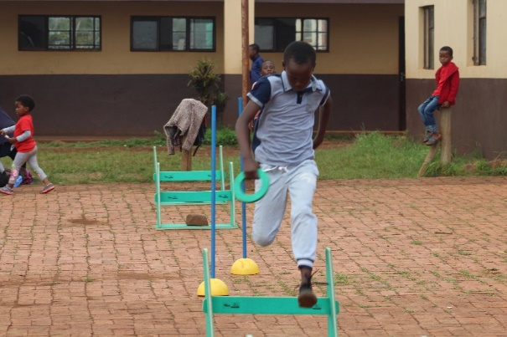

Here is the full list of the shortlisted nominees
Outstanding Junior Sportsman
Final top three
- Cameroon Thomas Jele
- Melusi Lukhele
- Sisekelo Rio Matsenjwa

Outstanding Junior Sportswoman
- Lamulela Magagula
- Mitchelle Amor Shen
- Sikhulile Mahlalela

Outstanding Sportsman
- Thandukukhanya Dlamini
- Zweli Dlamini
- Sibusiso Matsenjwa

Outstanding Sportswoman
- Sindisiwe Maphalala
- Nonhlanhla Erykah Seyama
- Leticia Viana

Outstanding Sportsman – SPWD
- Thobani Zikalala

Outstanding Sportswoman – SPWD
- Nomsa Mkhonta

Outstanding Sports Team
- Under-17 Football national team
- Correctional Sunrise ladies VB
- 2018 National Bass Angling team

Outstanding Sports Coach
Final top three
- Mbuso Vilakati
- Mfanafuthi Vilakati
- Velekhaya Mthethwa

Outstanding Administrator
- Bonginkhosi Shabangu
- Bhekisisa Mkhonta

Outstanding Sports Leader
- Sizwe Mabuza
- Bonginkhosi Shabangu
- Maxwell Jele

Outstanding Sports Journalist

- Sibusiso Masilela
- Phathizwe Msibi
- Ashmond Nzima

Sports Star
- Lamulela Magagula
- Mitchele Amor Shen
- Sikhulile Mahlalela
- Zweli Dlamini
- Thandukukhanya Dlamini
- Sibusiso Matsenjwa
- Sindisiwe Maphalala
- Nonhlanhla Erykah Seyema
- Leticia Viana
- Thobani Zikalala
- Nomsa Mkhonta

